How to be an impactful leader: Impeccable leadership


Are you entrusted with the responsible task of leadership? In that case, you know that you are dealing with a different force field. You are facing the challenge of meeting organizational ambitions and achieving goals and targets within a set time frame. However, you are not working alone. To realize purposes, you are leading one or more teams, and you will have to deal with differences in views and interests as well as relationships – in short, a new social complexity. Merely acting on intuition will only work to a certain extent. To find your way in this chaos, you need ‘glasses’ that allow you to see what is going on exactly – to see what it takes to succeed. But where do you start?

Solid foundation
In this whitepaper, we outline how leaders can fathom social complexity by development stages. Gaining insight into these steps will give you a guideline for being an impactful leader. After reading it, you will know what to do to improve collaborations and get through to each other to achieve results. By allowing everyone to come into their own and contribute to realizing the set objectives, you will lay a solid foundation for impactful leadership!

Why is impactful leadership crucial?
Leadership is about the ability to involve others in the process of goal achievement. This ability is closely related to your personal development as well as the extent to which you know yourself. Many leaders are not aware of the impact their behavior has on others. The risk is that you have a blind spot that causes unintended effects – which, in turn, can get in your way. Impactful leadership is an inner process; the more familiar you are with your perception, emotions, and thoughts, the higher your influence will be in a social context. If you gain insight into your behavior, you can use it with more impact to achieve goal realization. Consequently, leadership also requires that you are open to self-reflection and self- transformation.

Additionally, it is important that as a leader, you can read the behavior of individuals and the behavior of a team as a whole. After all, this allows you to understand what is happening. If you can properly identify behavior and place it in a particular development stage, you can link the right response to it. This is important because every development stage requires specific behavior that contributes to a transition to the next phase, in which quality and collaboration increase. By advancing to each consecutive stage, you work towards a joint creation of a cooperative system. And this is a prerequisite for success – which makes impactful leadership crucial.

What issues do you encounter?
One challenge that leaders face is rooted in relationships. In collaborations, these can lead to excellent performances, but also to stagnation, a lack of collaboration, and even conflict.
An excellent performance arises when a collaboration yields more than the sum of the individual team members’ achievements. Let’s draw a comparison with music. The notes, the instrument, and the musician are required to make music. However, they are not enough to capture an audience. Only when all the parts combine into a creative dialogue and the music starts to play, magic can arise, because of the parts that ‘lift’ each other. Then, the music is more than the sum of the parts – that is, the whole can transcend the sum of the parts. And achieving this transformation is the challenge a leader faces.

Another challenge is that individual team members are often motivated until they meet their leader. This may be the case because as a manager, you unintentionally discourage your employees with your behavior, because you are focused on achieving business goals. Not paying attention to the relationships with and perceptions of your employees may result in unintended stagnation. People will display commitment, but at the same time, they will not meet agreements or otherwise refrain from cooperating efficiently on achieving the set goals. The trick is to match the perceptions and needs of your employees and to place these within the requirements for your department’s success. You can do this by becoming aware of your behavior as well as that of others and by placing your organization, which is evolving, in a development-oriented framework. If you do this correctly, you and your team will keep advancing to each consecutive stage.

The three development stages
Impactful leadership starts with identifying a group’s level of development, consisting of three phases. Each stage characterizes a requirement that can be met by a leader. If you take the right step, transformation occurs, and a group can evolve towards the next stage. If this does not happen, there is a risk of stagnation. We will discuss the three stages of development below. If you go through these with your team, impactful leadership will likely be within reach.

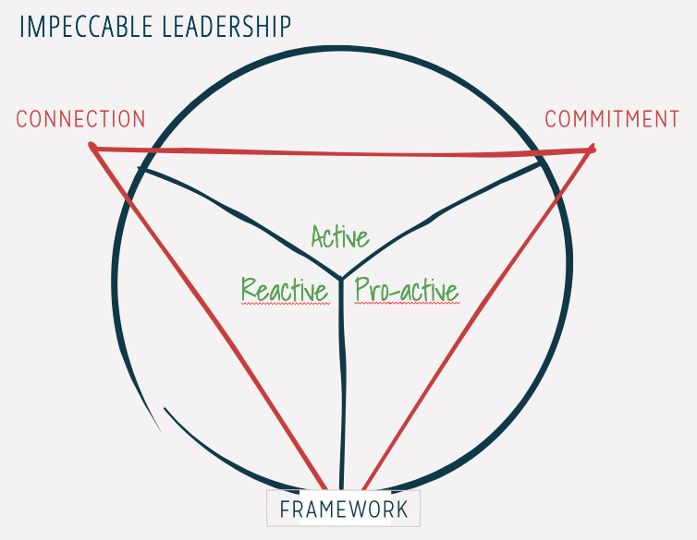
1. Reactive phase
Reacting is central to this stage. People do not yet feel safe and assume a cautious wait-and-see attitude. They exhibit derivative behavior or use strategies to protect themselves.
Many organizations show a high-to-low management structure: a pyramid game in which things such as position and social status is scarcely divided. This will quickly throw you into a struggle; you will want to show the upper layers your best side while firmly keeping control of the lower layers to secure your position concerning the top layers. This dynamic creates a potentially unsafe situation for people in an organization because they risk losing. As soon as the human brain – a social organ – detects a potential threat, it falls back on protective behavior, and individuals try to create safety for themselves. As a result, you can quickly get in each other’s way on the surface – or, at a behavioral level. We find common ground in a deeper understanding of perception. Therefore, it is crucial to observe ‘beyond behavior.’ This involves people’s feelings. Looking at things at an emotional level allows for a real connection to emerge. And that is what you need to advance.

What can you do?
How can you navigate through these challenges? In this stage, it is vital for a leader to outline management lines, along which you can shape your behavior. Your starting point is the fundamental task. A clear and well-defined framework of what you wish to accomplish will assist you in navigating through social complexity. It will serve as a polar star that helps you give and maintain direction.

Start by defining the intrinsic framework employing a broad perspective. Place your team’s objective in a full context by seeing it as part of the strategic ambition. If you know your department’s specific task as well as the organization’s strategic ambition, you can look beyond the team’s interest. Once you have mapped such things, you can take steps along the first management line. The first line is the connection. This means creating a room within your team to ensure that everyone feels safe and comfortable. That is what employees need in the first place to come into action. People feel safe and comfortable if they know your intentions at both a substantive and a relational level. A prerequisite is that you are authentic and that your behavior comes from within. Therefore, it is crucial to show who you are. Additionally, it is essential that people can exert influence (substantive level) and are accepted as human beings (relational level).

A first step in establishing a connection is creating a warm welcome and inviting people to express themselves. Suppose you are in a meeting, and as a team leader, you are telling everyone about the joint task. While doing so, you invite people to express how they look at the work (substantive level) and how they feel about it (relational level). Together, you focus on what is crucial for you as a team: what is the challenge and what is your common ground? Also, ask your team members how they feel about the activities you will carry out. This way, you are listening to the feelings, interests, and needs at play. You encourage them to refrain from hiding their opinions. After having started this, you can subsequently discuss the further development of the work with your team to realize the ambitions. In this context, you can ask: What issues do we encounter as a team in our collaboration? What bottlenecks are you experiencing as an individual? What do you need? By asking such questions, you invite team members to move to the next development stage. Whether this will happen depends on the degree of connection; if you have created trust and people feel safe, they are more likely to reveal what they are truly thinking and come into action.

2. Active stage
If you have created an authentic connection, you and your team will move to the active phase, which characterizes people openly expressing themselves in the group. Group members are ready and willing to buckle down. The importance of collaborating is recognized. Group members dare to voice their opinions and discuss the solution that they have envisioned. This work runs along the second management line, which is aimed at commitment. In the active stage, you embark on an exploratory journey and you achieve goal integration. Many leaders mistakenly believe that in this phase, they have to know ‘what things should be like’ or what the best solution is. This idea makes it difficult to involve others in goal realization truly. If you succeed in perceiving your ideas as one of the possible options, it is easier to listen carefully to people’s views, expertise, and interests. This will help you discover the requirements for a solution as well as the way in which you can ensure that the entire team supports the endeavor. In fact, you are jointly establishing a creative process to find a way that leads to the realization of ambitions.

In this creative stage, dilemmas will also surface. These should be explored and addressed in a connecting manner. It is important that you do not avoid dilemmas, but welcome creativity to find innovative ways and solutions. Do not strain people by taking substantive measures too quickly; open doors and windows at a substantive, social, and strategic level. Together, you will find options and formulate criteria to define the most fruitful path.

What can you do?
As hefty, previously dormant disagreements can surface during the implementation in the active stage, this can be a challenging stage for the leader. Nevertheless, it is important to look for different opinions, views, and interests within your team. Conflicts that are not discussed openly can sabotage things later in the process and may eventually become obstacles to success. Did you manage to identify differences in opinion? Then your next challenge is to not handle them in a way that is too directive! For example, you should avoid a response like, “Thank you for reporting this, but you need to adhere to the frameworks so, we will do it my way.” Such answers make your employee return to the reactive stage and may lead them to become cynical. This makes it difficult for your organization to change.
So, create a place where everyone can express their vision. Try to connect the different views and interests creatively and lift them to the higher level of solutions. If you facilitate difficulties, everyone can get to work without concern. Ultimately, you will jointly reach commitment. This way, you will work towards a cooperative system, which will pay off.
Finally, it is essential to make decisions at the end of the active stage. Make sure you do not get stuck in endless abstractions, ideation, and indecisiveness. Your current goal is to enter the third stage! As a leader, you cannot delegate this responsibility for making a final decision. The extent to which your team shows commitment depends on the process that preceded the decision- making process. The higher the involvement, the more proactively the team will operate.

3. Proactive stage
In this stage, the focus lies on providing added value. The third management line, which is aimed at realizing the ambition that makes the group’s purpose explicit, starts here. Terms that are central to the proactive stage are ‘delivering’ and ‘renewing.’ Now, it is important to act beyond specific or ‘micro-level’ interests – those of your team or individuals. You need to keep the interest of the ‘organization as a whole’ in mind and act on it, even if it does not suit your team or you at a personal level. The awareness, connection, and creativity of the previous two stages have laid the foundation for a proactive collaboration with the whole being more than the sum of its parts. It is wonderful that you can look at the way in which reality is evolving both as an organization and as a team. You are open, tolerant, and inquisitive, and you have a learning system. And because you are capable of establishing and renewing connections as a leader, you will always stay ahead of the game.

What can you do?
Think beyond your interests and those of your department and keep the interest of the whole in mind. If someone in your team can, for example, participate in a project that he wants to be a part of based on his development and ambitions, but the project is beyond the responsibility of the team, it may be at the expense of the departmental interest. However, the organization as a whole does benefit from an individual taking steps regarding his personal development. So, if you look at the big picture, you will decide beyond your department’s interest: you will allow your team member to participate in the project.
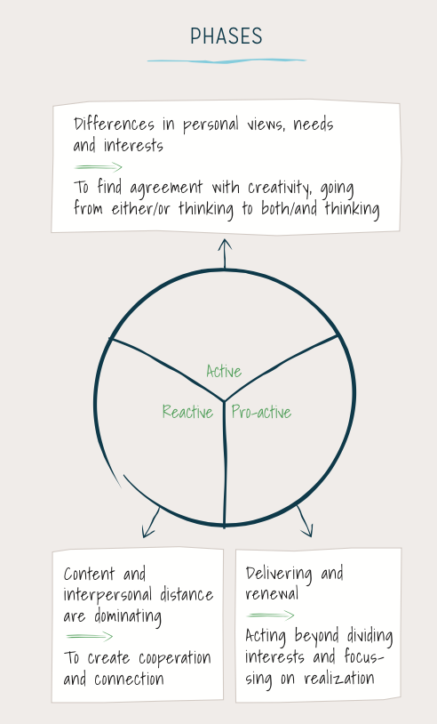
A quest for meaning and a focus on the interest of the entire organization are central to this stage. You have become so familiar with the patterns and strategies in your development that you can make decisions in the interest of the overall whole, even under pressure. Here, the inner game (being aware of your behavior) and the outer game (the performance of your team and organization) come together: through powerful leadership development, you can help your co-workers, team, and organization advance.

The outcome of impactful leadership: a community of excellence
Going through the three development stages has allowed you to establish a creative performance system. This way of collaborating is a prerequisite for success. Only if people are intrinsically motivated to cooperate on team goals, there will be an excellent performance. If something goes wrong at a relational level, it is important to realize it. By solving such problems and by successfully going through the three stages, you allow for a gradual emergence of a community of excellence, which consists of team members that support each other and ‘lift each other up.’ This is where the ‘music’ is created. In each stage, you and your team are like a caterpillar that rids itself of its cocoon on the path towards the next stage to evolve into a butterfly.

You should realize that the process is dynamic; it never ends. In fact, you are constantly spiraling upwards in your development. It is important always to be aware of the complexity that you are dealing with. Fairly constant factors and less volatile things (such as legislation) are complemented by unpredictable elements which are subject to change. You can keep on track by keeping the big-picture task in mind on the one hand and incessantly continuing the dialogue on individual interests and views on the other. Moreover, you constantly need to be aware of your requirements for continuing to function properly. This will allow you and your team to achieve joint behavior and creative solutions to realize ambitions. Impactful leadership ensures that you can meet your ambitions!

Would you like to learn more about impactful leadership?
Do you have any additional questions regarding impactful leadership after reading this whitepaper? Or do you simply want to learn all about it by practicing, training, and experiencing, so you can get started with it as soon as possible?

Impeccable leadership
www.impeccable-leadership.com

